**TUGAS RPL**

**(DFD & ERD Rancangan Sistem Informasi)**

**__________________________________________________________________________________________**

Anggota Kelompok :

* Reka Nurbitono (2110147031)
* Hilman Abu Dzarrin (2110147040)
* Soleh Elfrianto Hardiyono (2110147044)
* Rindang Naffi’Atu Laila (2110147052)
* Muhammad Khamim Munir (2110147053)
* **Judul :** Sistem Pelaporan K3
* **Conseptual Data Model (CDM)**

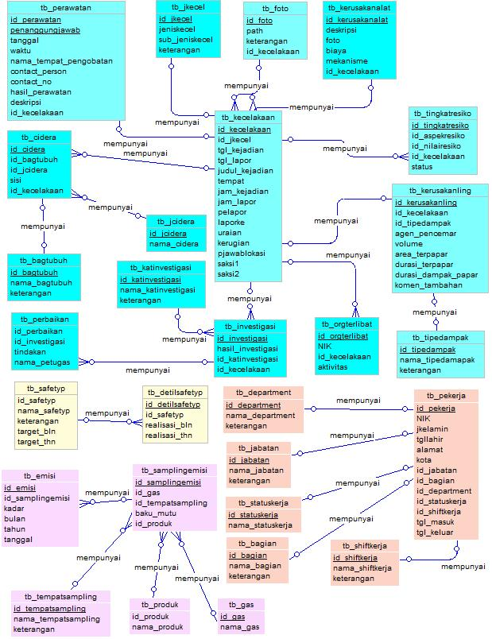

* **Physical Data Model**

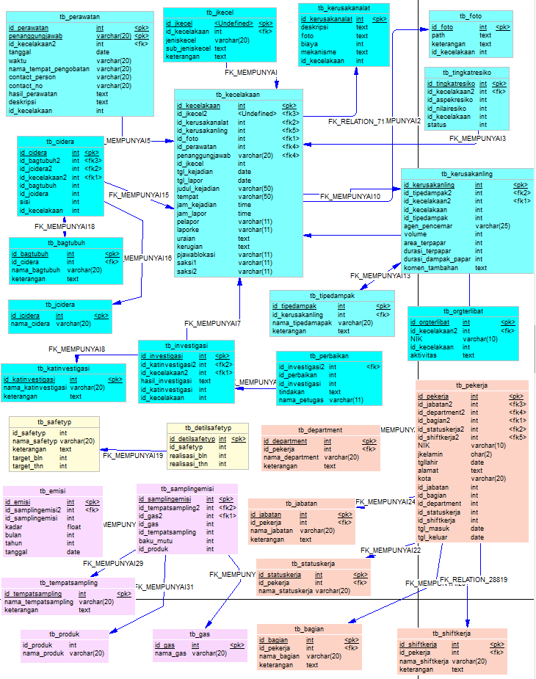

* **Data Flow Diagram (DFD)**

1. **Level 0 (context diagram)**

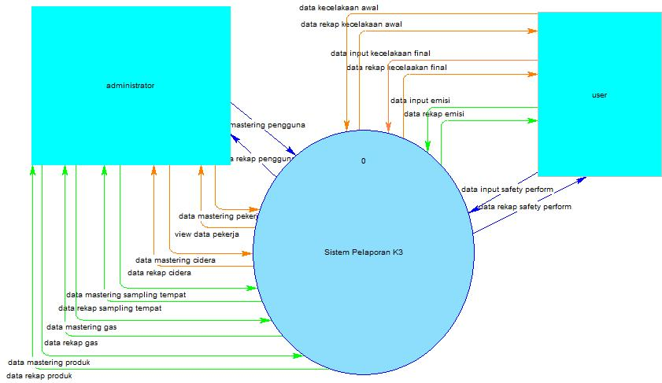

1. **Level 1**

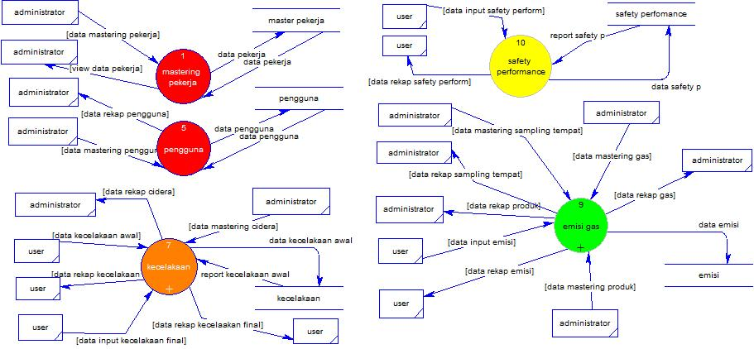

1. **Level 2 (kecelakaan)**

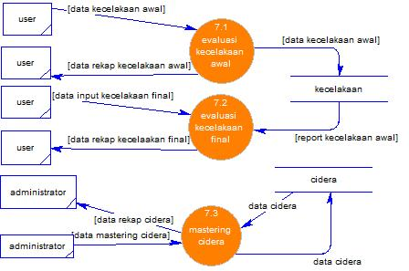

**Level 2 (emisi)**

